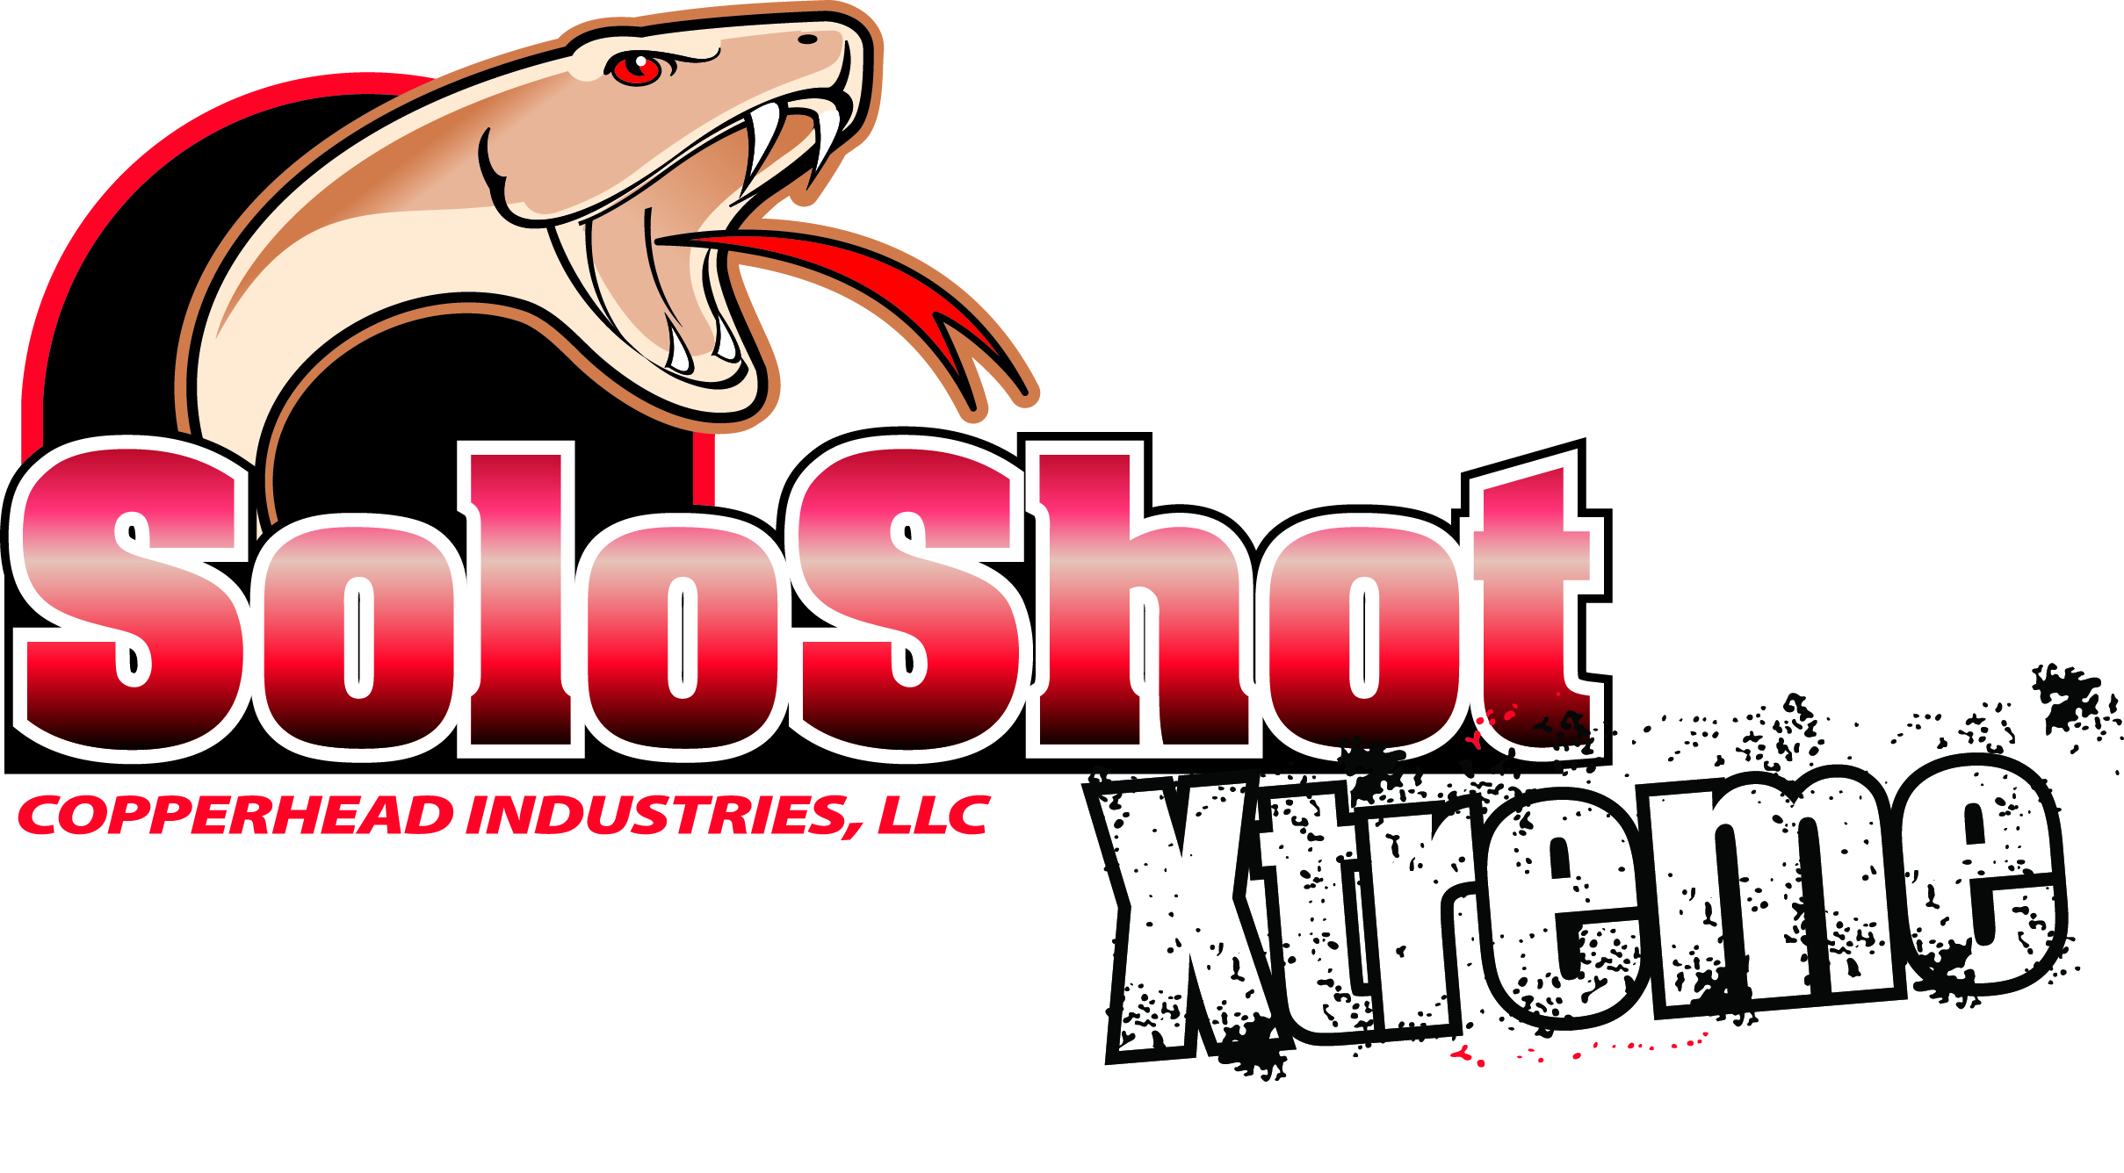

Copperhead® SoloShot™ Xtreme
For Pipe Bursting and Extreme Horizontal Directional Drilling Applications:

- Use Copperhead® SoloShot™ Xtreme Tracer Wire
- Part# PBX*-50-**. Manufactured specifically for pipe bursting and difficult HDD applications
- * = Color: B=Blue Water, G=Green Sewer, P=Purple Reclaim Water Y=Gas
- ** = Minimum Quantity 500’, Custom lengths available beyond 500’ in 100’ increments, Quantity discounts at 5000’ +

Tracer wire for Pipe Bursting shall be Copperhead SoloShot™ Xtreme, 7x7 stranded Copper Clad Steel, insulated with a 50 mil, high-density, high molecular weight polyethylene (HDPE) insulation, and rated for direct burial use at 30 volts. HDD conductor must be at 21% conductivity for locate purposes, break load will be 4700 lbs. minimum. HDPE insulation shall be RoHS compliant and utilize virgin grade material. Insulation color shall meet the APWA color code standard for identification of buried utilities. Manufacturers supplying copper clad steel tracer wire must have available detailed performance data including 5 years of underground testing in terms of durability related to damage of protective insulation and effects of potential corrosion of the specific copper clad steel used. Origin of copper clad steel manufacturer is required and steel core must be manufactured in the United States. If manufacturer has not completed 5 year corrosion testing, a 5 year warranty must be provided. Tracer wire shall be Copperhead® SoloShot™ Xtreme Tracer Wire. HDD HDPE 50 mil or district pre-approved equal and made in the USA.

Copperhead Industries LLC, PO Box 1081 Monticello, MN 55362∙Ph 877-726-5644∙Fax 763-271-3694 www.copperheadwire.com

